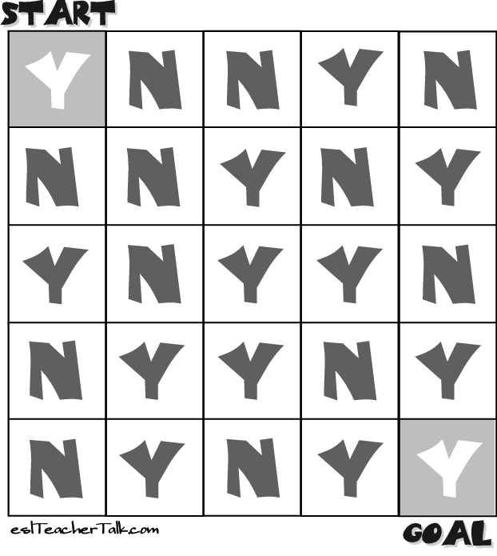

headache yes - no allergies yes - no
fever yes - no medication yes - no
cough yes - no seen a doctor yes - no
pain yes – no other problems yes - no
headache yes - no allergies yes - no
fever yes - no medication yes - no
cough yes - no seen a doctor yes - no
pain yes – no other problems yes - no

headache yes - no allergies yes - no
fever yes - no medication yes - no
cough yes - no seen a doctor yes - no
pain yes – no other problems yes - no
headache yes - no allergies yes - no
fever yes - no medication yes - no
cough yes - no seen a doctor yes - no
pain yes – no other problems yes - no

